Faculty of Computers and Artificial Intelligence

Computer Science Department

Selected topics

system Fall semester 2021-2022

Team members number:7

|  |  |
| --- | --- |
| Id | **Name** |
| 201900542 | عمرو محمد عطاالله |
| 201900526 | عمر محمد سعد |
| 201900731 | محمد مختار محمد |
| 201900545 | عيد خالد عاشور |
| 201900989 | يوسف علاء الدين أحمد |
| 201900835 | مصطفى ناجح فتحي |
| 201900665 | محمد خالد مصطفى |

Paper details:

**Author name:** Iftekher Mamun

**Paper name**: A Simple CNN: Multi Image Classifier

**Year of publication**: Apr 7, 2019

**The dataset used**:  [animal-10 dataset](https://www.kaggle.com/alessiocorrado99/animals10)

General Information on the selected dataset

We have an image dataset that include images mountains, streets, glaciers, buildings, sea, forest

**Name of the dataset:** Intel Image Classification

**Number of features:** 17000

**The dimensions of images:** 150, 150, 3

**Number of classes:** 6

Implementation details

**Training examples:** 11.200

**Test examples:** 3000

**Validation examples:** 2800

**Hyperparameters:**

* **Batch size: 128**
* **Epochs: 55**
* **Learning rate: 0.001**

Visualizations:

**Train and test examples**

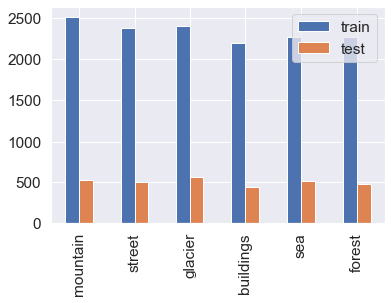

**Proportion of each observed category**

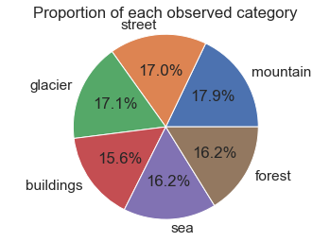

**PCA Matrix**

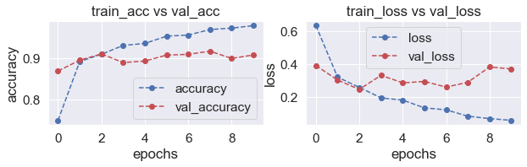Accuracy and Loss

Confusion matrix

